## The physical system : Lab-scale manufacturing system

The real manufacturing system used in this study is a two station closed line which follows the previous features and connections explained in Section “ platform”.  
The lab-scale model is illustrated in Figure.

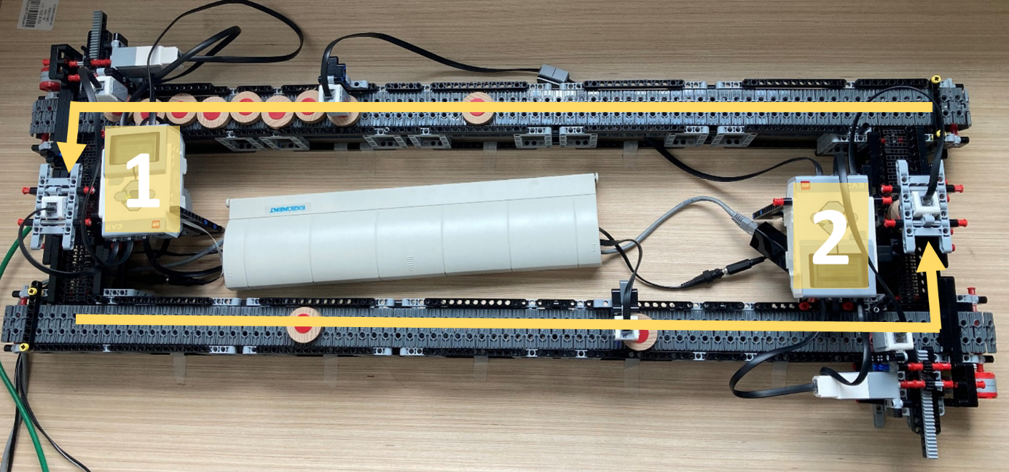

As previously introduced in Section “platform “ no further explanations are needed.

## The demonstration: Settings and results

A demonstration is set in order to verify the functioning and study the contributions of the platform.  
The lab-scale production line represents an operating system operating for limited time-shifts distanced by switched-off periods.   
Each operating period is set to be 40 minutes, during which the several components collaborate to let the DT show its capabilities.   
The physical system is characterised by : perfectly reliable machines, processing of a part one at the time, Blocking After Service (BAS) discipline and buffers capacity of 8 pallet with 12 pallets circulating. The two stations are configured to process pallets with defined distribution parameters: Machine1: *Triangular(3,8,5)* and Machine 2: *Triangular(2,5,3).*

The digital components are tuned to perform appropriately, with the aim of effectively and efficiently achieve the purposes determined.  
Settings have been defined by the knowledge acquired from the previous tests. Further studies might support in the definition of the optimal parameters but they would strictly be related to the objectives and real conditions of the system.  
Regarding the controller components’ settings the table shows the parameters used for this demonstration.

|  |  |  |
| --- | --- | --- |
| **Components** | **Sub-components** | **Settings** |
| **Controller** | Generator & Converter | t_horizon: *10m,* freq:*marker dependant* |
| Synchroniser | t_horizon:*5m,* freq:*marker dependant* |
| Update | t_horizon_dist:*10m,* freq:*marker dependant* |
| **Simulator** |  | Simulator_type: *“Manpy”, use_type:”sync/forecast”* |
| **Evaluator** |  | Forecast rep :20 , simulation time: dependant on time demonstration left |
| **Analyser** |  | t_horizon: *10m,* freq: ½ s |
| **Validator** |  | t_hozion:10m, freq:1/60 s |

Furthermore, it is fundamental to define some of the markers used by the controller. In particular the one checking the logic and the other related to the input distribution updated.  
Certain thresholds are to be investigated and tuned to correctly inform the controller about the misalignment conditions. This elaboration is performed through the work of Gangemi et al.. and the information are transmitted as binary, triggering the respective alignment action.

Parallelly, the third marker is related to check synchronisation conditions. Following the explanation of Section 4 “ Platform”, for this case the threshold is imposed to be equal to 0. As a consequence no degree of misalignment when it comes to instant conditions is allowed.

The markers and parameters are optimized to achieve the objectives of demonstrating the capabilities of the DT. While the alignment is assured, a demonstration plan is used to address the purposes of monitoring, conduct forecast and what if analyses.  
In particular, during one shift a degradation trend is applied to one of the station. Once the events is detected, the digital platform runs a series of forecast analyses. Different options scenarios are tried with the aim of solving disruptive pattern and optimizing the production within the end of the shift. Once the best solution based only on the amount of parts produced is found, without considering any cost-based information, it is automatically applied to the real system and the demonstration ends.

The steps which compose the demonstration schedule are shown in Figure.

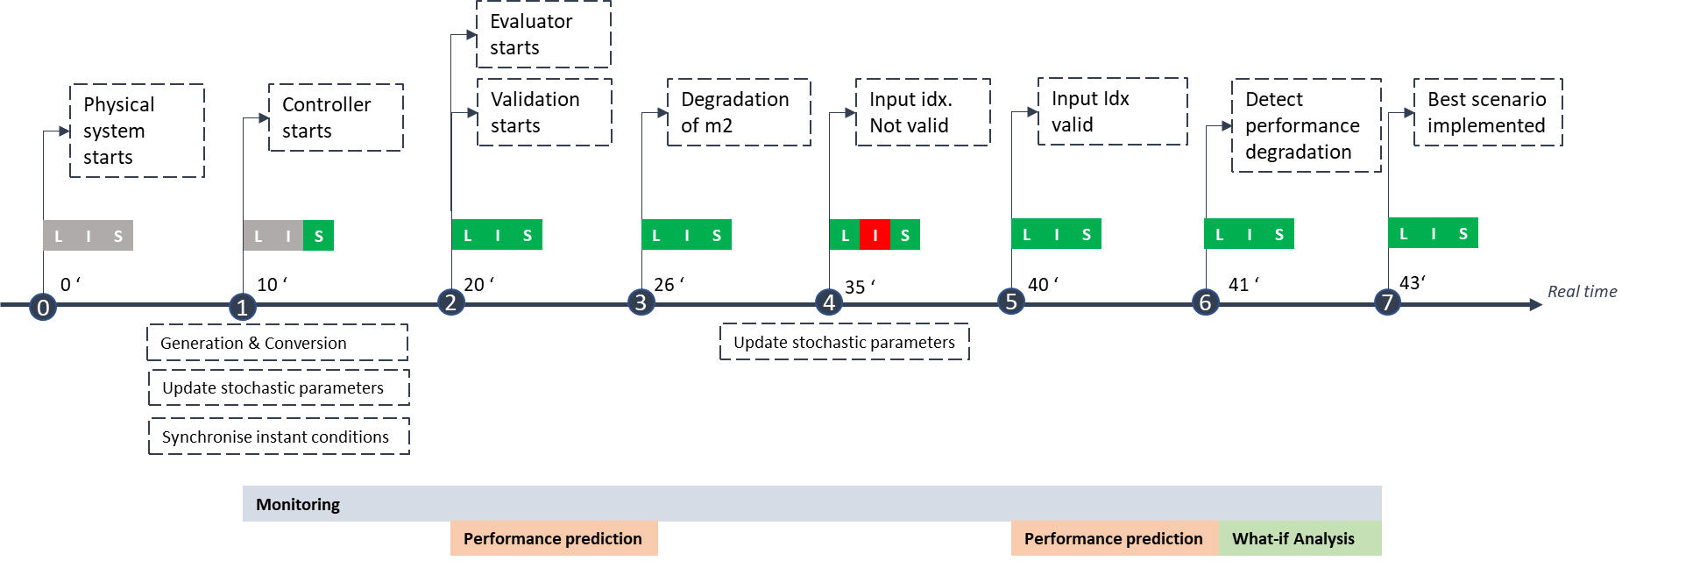

A plan has been defined to structure the stream of actions which occur during the demonstration.

* Real system
* Settings
  + Real
  + Digital
* Demonstration plan- timeline
* Monitoring results
  + Alignment procedure verified:
    - System time, Interdeparture Time
    - Parameters update
  + Digital performance add-in
* Disruptive event detection
* What if analyses performed